# Core Concept

This is a 2D endless vertical scroller platformer game. The player must jump on randomly generated cloud platforms endlessly for the highest score in a single game.

# Inspiration Games

There are many vertical platformer games and is not an original concept, but I wanted a game that followed a vertical-held position as it could be easily opened by a user who is normally holding their phone without needing to rotate it.

Doodle Jump is a mobile vertical platformer released in 2009. Something that is unique about Doodle Jump is the style, which inspired the design of my game. I also wanted to simplify the gameplay features, creating a small scope so I could focus on the functionality of the core mechanics, which includes platform jumping.

# Design Pillars

Responsive player touch input

Replayability

# Features and Mechanics

Touch and drag ball that will bounce on platforms.

Platforms that procedurally generate.

Parallax background

Time

Score

# Target Platform and Audience

I want to use the Android operating system for the mobile platform as it is a popular operating system for different brands of mobile devices. Android is also more accessible for downloading and installing the game.

# Interface and Controls

# Basic Story

A chicken—a flightless bird—dreams of flying and believes it can fly. Using the help of the player and the clouds in the sky, the chicken can scale upwards into the sky.

# Visual Style

# Design Sketches

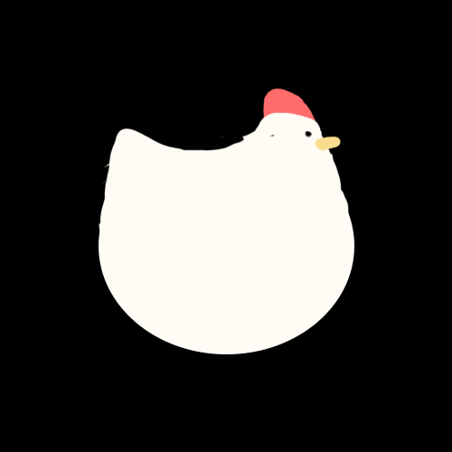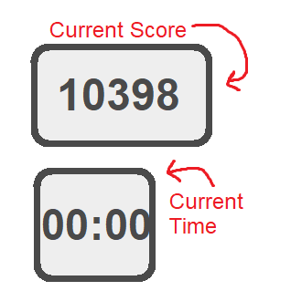

# Audio Style

# Known Issues and Bugs

# Future Improvements

# Game Link

<https://erikastuart.itch.io/chickens-can-fly>